**MINI PROJECT**

Report on

**“POPULATION STRATEGIST”**

Submitted in partial fulfillment of the requirements of the degree

**BACHELOR OF ENGINEERING IN**

COMPUTER ENGINEERING

By

**Arabinda Chand**

Guide

**Dr.Shital Agrawal**



**Department of Computer Engineering**

**B R Harne College of Engineering and Technology**

**Karav, Vangani (W) -421503**

**University of Mumbai (AY 2024-25)**

**CERTIFICATE**

This is to certify that the Mini Project entitled **“ POPULATION STRATEGIST ”** is a bonafide work of carried out by his/her under the supervision of Dr.Shital Agrawal, and it is submitted to the University of Mumbai in partial fulfillment of the requirement for the award of the degree of **“Bachelor of Engineering”** in **“Computer Engineering "..**

**(Prof. Shital Agrawal)**

Guide

**( Dr. Shital Agrawal ) (Dr. Vikram Patil )**

Head of Department Principal

**Mini Project Approval**

This Mini Project entitled “**POPULATION STRATEGIST”** by ARABINDA CHAND is approved for the degree of **Bachelor of Engineering** in Computer Engineering **.**

**Examiners**

**1………………………………………**

(Internal Examiner Name & Sign)

**2…………………………………………**

(External Examiner name & Sign)

Date:

Place: KARAV

**Contents**

**Abstract ........................................................................................................................ 1**

**Acknowledgement ........................................................................................................ 2**

**List of abbreviations .................................................................................................... 3**

1. **Introduction ...................................................................................................... 4** 
   1. Introduction **4**
   2. Motivation **5**
   3. Objectives **5**
2. **Literature Survey ............................................................................................ 6-7** 
   1. Survey of Existing System **6**
   2. Limitation Existing system or research gap **7**
   3. Mini Project Contribution **7**
3. **Problem definition .......................................................................................... 8** 
   1. Problem Definition **8**
4. **Proposed System .......................................................................................... 9-10** 
   1. Architecture framework **9**
   2. Algorithm **9**
5. **Planning And Time Estimation ................................................................. 11**
6. **System Requirement…................................................................................ 12** 
   1. Details of Hardware  **6.2**Details of Software **12**

**System Design .................................................................................... 13-15**

* 1. Data Flow Diagram **13-14**

**6.4** Shared Preferences **15**

1. **Implementation ...................................................................................... 16-20**
2. **Testing…................................................................................................. 21-22** 
   1. System Performance **21**
   2. Observation **22**
   3. Test Case **22**
3. **Result Analysis… ....................................................................................... 23**
4. **Conclusion And Future Scope .................................................................. 24**

# ACKNOWLEDGEMENT

There are times when words cannot express our gratitude. It is with us, as we cannot find appropriate words that would express our deep sense of gratitude and satisfaction. We would like to take this opportunity to thank everybody who helped through the successful completion of this project. Many people have contributed to our achievements during the project and we take this opportunity to thank each one of them at end of the project durations.

First, we would like to thank our Principal Sir, H.O.D & our project guide Dr. Shital Agrawalwho has extended all her valuable guidance, help and constant encouragement through the various difficult stages involved in the development of the project.

We would like to express our heartfelt thanks to all who contributed their valuable experience and knowledge and provided constant guidance to us. Thus, we feel fully obliged and convey our thanks to the teaching as well as non-teaching staff of the department. Last but not the least we would like to thank to our project partners(books) for their efforts and help.

Last but not the least we are thankful to our parent and friends for their constant Inspiration, encouragement and well wishes by which we have made a challenging project.

|  |  |
| --- | --- |
| **List of Abbreviations**  DART:- Dart programming language  GUI:- Graphical User Interface  FBD:- SQL | 3 |

**CHAPTER NO.01**

# INTRODUCTION

## 1.1Introduction

**1.1.2Benefit:**

## 1.2Motivation

## 1.3Objectives

**CHAPTER NO.02**

**LITERATURE SURVEY**

**2.1Survey of Existing System**

### 2.2Mini project contribution

### 2.3Limitation of existing system

**CHAPTER NO.03**

**PROBLEM DEFINITION**

**3.1 Problem Definition**

**CHAPTER NO.04**

**PROPOSED SYSTEM**

### 4.1Architecture/framework

### 4.2Algorithm

### Flow Diagram Of Project

**CHAPTER NO.05**

**PLANNING AND TIME ESTIMATION**

**Planning And Time Estimation:**

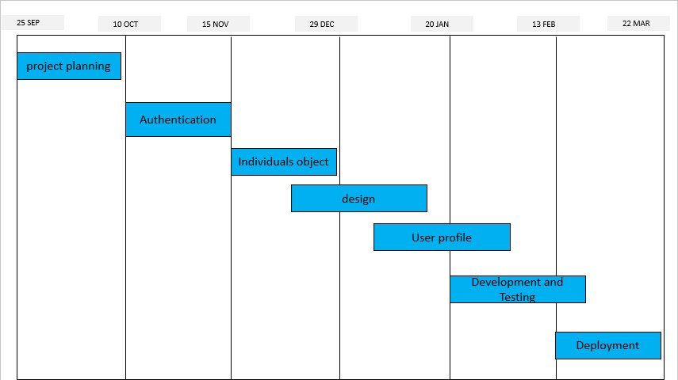

**Fig.5.1**

**CHAPTER NO.06**

**SYSTEM REQUIREMENT**

### 6.1Details Of Software

### 6.2Details Of Hardware

**CHAPTER NO.07**

**SYSTEM DESIGN**

### 7.1Data Flow Diagram (DFD)

**CHAPTER NO.08**

### IMPLEMENTATION

**CHAPTER NO.09**

**TESTING**

**CHAPTER NO.10**

**RESULT ANALYSIS**

**CHAPTER NO.11**

**CONCLUSION AND FUTURE SCOPE**

**Conclusion:**

**Future Scope :**

**REFERENCES**

**Journal paper:**

The Encoding/decoding model of communication was **first developed by cultural studies scholar Stuart Hall in 1973**. Titled 'Encoding and Decoding in the Television Discourse', Hall's essay offers a theoretical approach of how media messages are produced, disseminated, and interpreted.

**Book:**

# Information Hiding In Images Using Least Significant Bit Steganography Paperback – May 24, 2018

**Links:**

* <https://data-flair.training/blogs/python-message-encode-decode>.
* <https://in.search.yahoo.com/search?fr=mcafee&type=E211IN714G0&p=python>
* <https://www.makeuseof.com/python-base64-encode-decode-messages/>
* <https://www.makeuseof.com/python-base64-encode-decode-messages/>